**Question-1***: Monopoly and Perfect Competition*

**Price and Cost (BDT)**

**55**



**30 MC ATC**



**25**



**20**

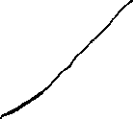

**15**



**MR D**



**4 6 Quantity (in million kg)**



a) What is the ***profit maximizing*** price and output if the firm is a ***monopoly***?

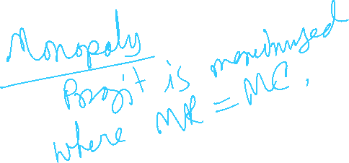

b) What is the ***profit maximizing*** price and output if the firm is a ***perfectly competitive*** one?



c) Under ***monopoly***, what is the economic ***profit/loss***? *(Show your calculations)*

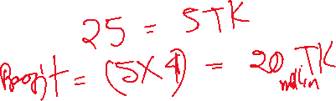

d) Under ***perfect competition***, what is the economic profit/loss? *(1 marks)*



*e) Calculate the deadweight loss of monopoly*

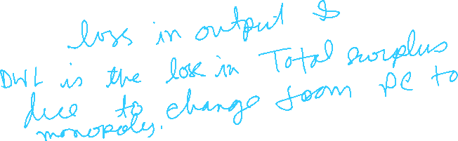

d) Which market is ***more efficient***? Explain your reasoning using the diagram above. *(Show your calculations*)

